**Lesson 22 Cíntia Domingos**

**Beet Seed**

**1.**

* Most expensive product:

SELECT Product_name, Price

FROM Shopping_list

WHERE PRICE = (SELECT(MAX(PRICE))

FROM Shopping_list);

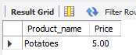

* Cheapest product:

SELECT Product_name, Price

FROM Shopping_list

WHERE PRICE = (SELECT(MIN(PRICE))

FROM Shopping_list);

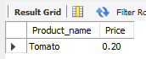

**2.**

SELECT AVG(Price) as Avg_Price

FROM Shopping_list;



**Beet Sprout**

**2.**

2.1

SELECT COUNT(*) FROM Fridge;

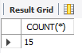

2.2

SELECT COUNT(*)

FROM Fridge

WHERE Product_ID <> 'NULL';

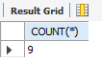

2.3

SELECT SUM(Quantity) AS Total_Fridge

FROM Fridge;

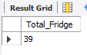

**Mighty Beet**

**2.**

SELECT expiration_date, product_name, sum(quantity)

FROM Fridge

GROUP BY Expiration_date, Product_name

ORDER BY Expiration_date;